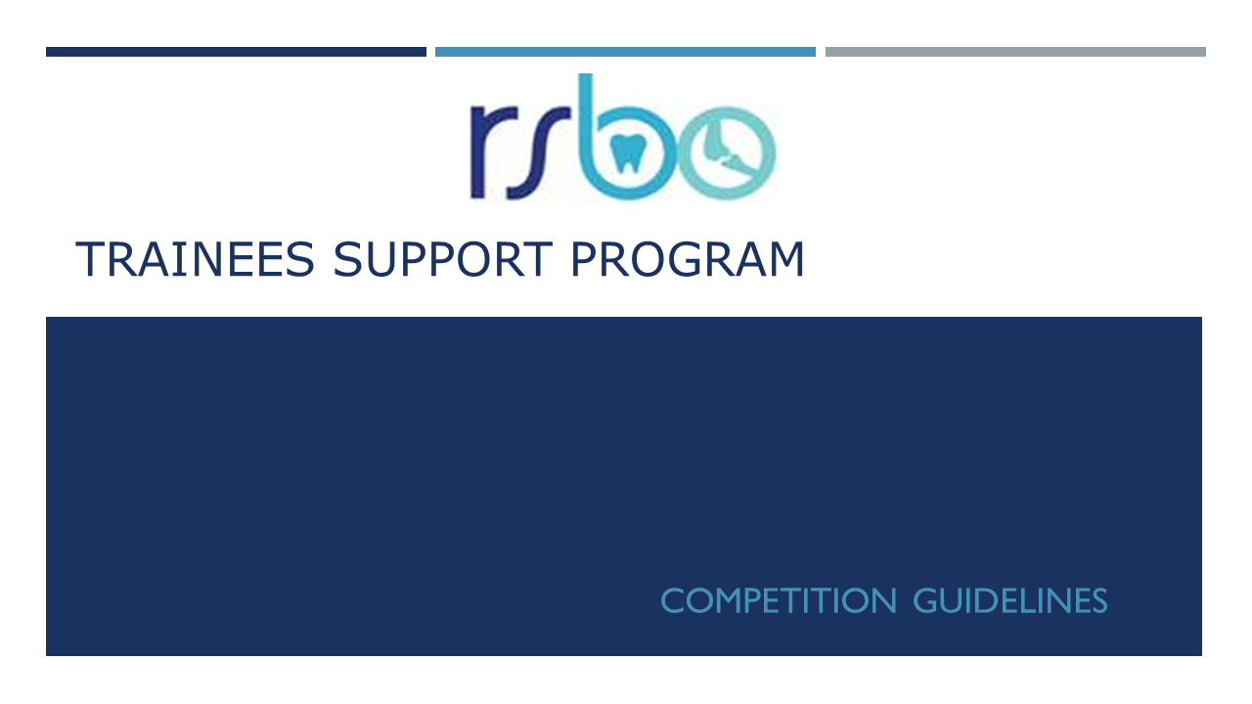
Deadline: August 20th, 2010, 5 p.m.
Results to be announced in October 2019
The RSBO network (Réseau de recherche en Santé Buccodentaire et Osseuse) is proud to support trainees involved in clinical, outcome and basic research. Our support program for trainees seek to promote multidisciplinary projects and collaborations with experts of diverse fields. Although not considered as an essential criterion, applications presenting a multidisciplinary project (basic, clinical, public health or entrepreneurial) will be received positively from the reviewers.
The FRQS offers fellowships allowances of $5 000 for M.Sc students and $10 000 for Ph.D. students and postdocs.

Eligibility criteria

- Be a student enrolled in a Master's or Doctoral program in a Quebec university and be supervised or co-supervised by a regular member of the Network for Oral and Bone Health Research. Although not mandatory, trainees presenting projects involving members from several axes of the RSBO will receive favorable views.
- Submit a project consistent with the Network's research priorities and in compliance with the ethical rules in force in the institution associated with the research;
- The financial support is cumulated only up to the equivalent amount awarded by funding agencies ($18,000 M.Sc. and $21,000 Ph.D.);
- A student is eligible to receive a maximum of two scholarships through this program (consecutive or not). When applying a second time, he/she must provide proof that efforts were made to obtain a scholarship from another funding agency;
- The awardees will be part of the RSBO trainees group with the mission of organizing events of interest for students members of the RSBO.
Required documents

The application form along with the requested documents (see below) in one PDF including:
- a recommendation letter from the supervisor
- the description of the project (maximum 2 pages, font 11, single space, 2,5 cm margins)
  - Introduction
  - Objectives
  - Methodology and timeline
  - Data analysis plan
  - Relevance to oral or bone health
- in the case of a second application, list on a separate page the scholarship applications submitted in the past year. If none, explain why.
- a biosketch (maximum 4 pages, font 11, single spaced, 2,5 cm margins)
  - training: diplomas obtained, field, university, year
  - scholarships obtained: agency, year, amount awarded
  - prizes and distinctions
  - posters and oral presentation: authors, title, meeting, location, year
  - publications: authors, title, journal, year
  - other relevant work, clinical or research experience
- New document for postdocs: Career Plan: describe in 1 page how your scientific environment is suitable with your career goals

Documents should be send by email to:
Andrée Lessard
Coordinator/Manager
Réseau de recherche en Santé Buccodentaire et Osseuse
andree.lessard@mcgill.ca

