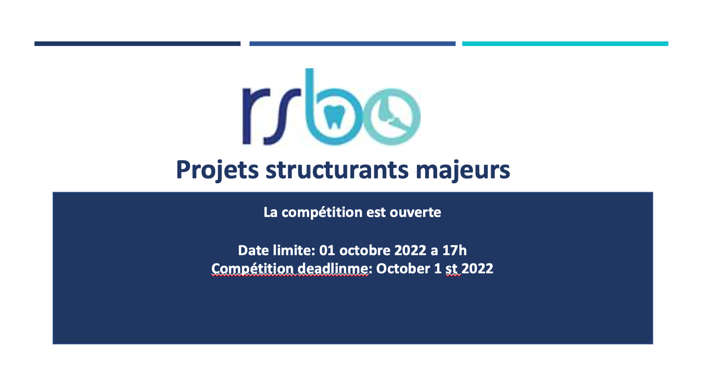
Competition Deadline: October 1st, 2022 at 5 PM
The results will be announced in December 2022
Funds available: 50 000$ for 1 year (renewable under conditions)

New in 2022
The RSBO dedicates the budget of the 250 000$ to fund this program and accept any applications on oral or bone health.
Note that this competition is in collaboration with the Ministry of Health and Social services (MSSS)

Rules and Compliance
All researchers that are funded through this program must comply to the rules and regulations of the Fonds de recherche du Québec, which can be found in Les règles générales communes who describes, among other rules, eligible expenses.
The RSBO is expecting acknowledgement of their support in any communication or publications generated through the funded project. The RSBO reserves the right to request a list of all publications or abstracts that result from the project funded through this program.
The RSBO reserves the right to contact researchers to produce a short video (2-3 minutes) of the funded project.

This program seeks to:
- Facilitate collaborations between researchers from different locations, fields and expertise’s around common research themes,
- Support researchers in developing innovative projects that will increase their chances to obtain major grants from national or international agencies,
- Generate substantial scientific knowledge that will contribute to major discoveries which ultimately will impact the scientific community as well as the public.

Eligibility Criteria
- The Principal Investigator must be a regular member of the RSBO.
- The research team must include at least three members from at least two different institutions.
- A regular member can submit only one application as a principal investigator.
- A principal investigator cannot apply for this competition if they already received funding from our previous competition (Fall 2021) as principal investigator.
Required Documents

Please fill the application form available on our web site, send it with all the required signatures (principal investigator, co-investigators, and all other researchers) to intissar.abbaoui@mcgill.ca before 5PM on October 1st, 2022.
Evaluation Criteria
- Quality of the research project (relevance, innovation, creativity, potential impact, budget and timeline)
- Knowledge transfer and Leverage effect
- Excellence of team members (levels of expertise’s, Bio Sketch’s);

