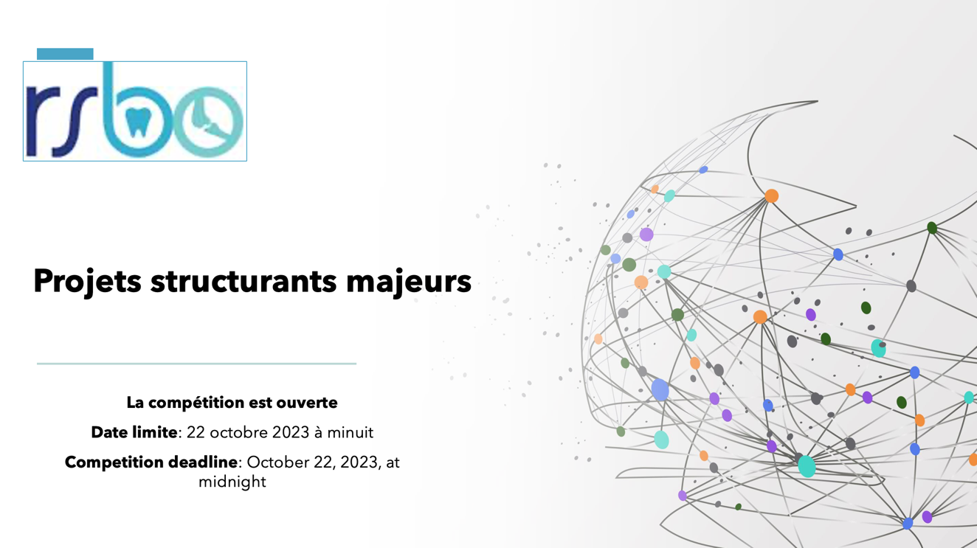
Competition Deadline: October 22, 2023, at midnight
The results will be announced starting by January 2024
Funds available: 40 000$ or 50 000$ for 1 year (not renewable)

New in 2023
The RSBO dedicates a budget of approximately 250 000$ each year to fund this program and accepts any applications on oral or bone health. This year, we will finance several major structuring projects each worth 40 000$. However, one of the projects will be financed in partnership with the FODQ (foundation of Quebec’s order of dentists) with an amount of 50 000$, provided that it relates to accessibility to dental care (the FODQ favors projects aimed at improving accessibility to oral care for the most vulnerable people).

Financing conditions and commitment of recipients
- All researchers that are funded through this program must comply to the rules and regulations of the Fonds de recherche du Québec, which can be found in Les règles générales communes who describes, among other rules, eligible expenses;
- The RSBO is expecting acknowledgement of their support in any communication or publications generated through the funded project;
- Submission of a report at the end of the grant. The latter will summarize the progress of research results, published articles, summary of scientific presentation;
- The RSBO reserves the right to contact researchers to produce a short video (2-3 minutes) of the funded project;
- The RSBO reserves the right to ask researchers to make oral presentation for network’s scientific days to share the results of their projects funded by RSBO.
This program seeks to:
- Facilitate collaborations between researchers from different locations, fields and expertise’s around common research themes,
- Support researchers in developing innovative projects that will increase their chances to obtain major grants from national or international agencies,
- Generate substantial scientific knowledge that will contribute to major discoveries which ultimately will impact the scientific community as well as the public.
Eligibility Criteria
- The Principal Investigator must be a regular member of the RSBO.
- The research team must include at least three members from at least two different institutions.
- A regular member can submit only one application as a principal investigator.
- A principal investigator cannot apply for this competition if they already received funding from our previous competition (Fall 2022) as principal investigator.
Evaluation Criteria
- Quality of the research project (relevance, innovation, creativity, potential impact, budget, and timeline)
- Knowledge transfer and Leverage effect
- Excellence of team members (levels of expertise’s, Bio Sketch’s)
Required Documents
Please fill the application form available on our web site, send it with all the required signatures (principal investigator, co-investigators, and all other researchers) to intissar.abbaoui@mcgill.ca before midnight on October 22, 2023.

